MAP ASSIGNMENT-5
1) Configuring a Mule 4 Application for File Read and Write Operations (with Flow Diagram)

In Mule 4, we can easily perform file operations such as reading from and writing to files by designing a simple flow. Below is the step-by-step procedure to configure these operations.

Step 1: Create a New Mule Project
- Open Anypoint Studio and create a new project named fileoperations.

Write Operation Flow
- Add an HTTP Listener
  - Drag the HTTP Listener component onto the canvas.
  - Set the Path to /write.
  - This component will listen for incoming requests to trigger the write operation.
- Add a Transform Message Component
  - Place a Transform Message component after the listener.
  - Use DataWeave code here to generate a JSON payload containing student details.
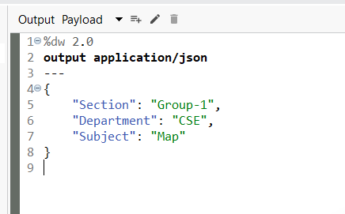
- Add a Write Component
  - Drag the Write component next in the flow.
  - Configure the following:
    - Path: C:\AnypointStudio\FileOps\hi.txt
    - Content: payload
    - Write Mode: Overwrite (default setting)
  - This step creates a file named hi.txt (or overwrites it if it exists) and writes the generated JSON data into it.
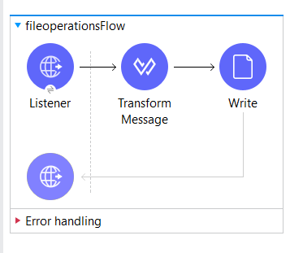
- Deploy and Test the Application
  - Save and run the Mule app.
  - Open Postman and send a request:
    - Method: POST (or GET, as per configuration)
    - URL: http://localhost:8081/write
  - A file named hi.txt should now be created at the specified location with the JSON content inside.
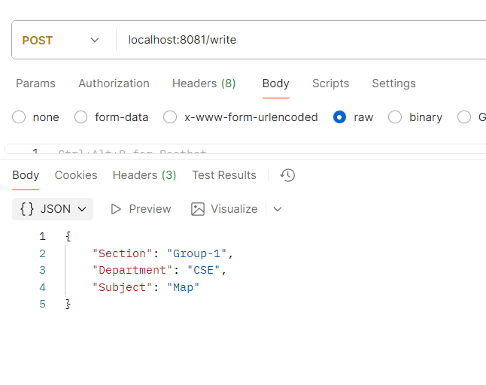
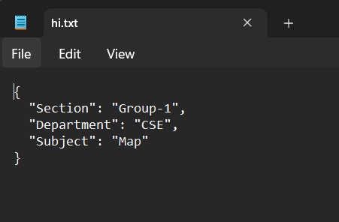

Read Operation Flow
- Add Another HTTP Listener
  - Add a new HTTP Listener component.
  - Configure its Path as /read and Method as GET.
- Add a Read Component
  - Drag the Read component after the listener.
  - Set the Path to C:\AnypointStudio\FileOps\hi.txt.
  - This reads the contents of the previously created file.
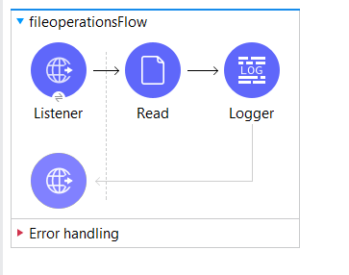
- Add a Logger Component
  - Drag a Logger component after the Read component.
  - Set the Message as #[payload].
  - The logger will print the contents of the file to the console.
- Test the Read Operation
  - Run the Mule application and open Postman.
  - Send a GET request to http://localhost:8081/read.
  - The contents of hi.txt will be read and displayed in the console logs.
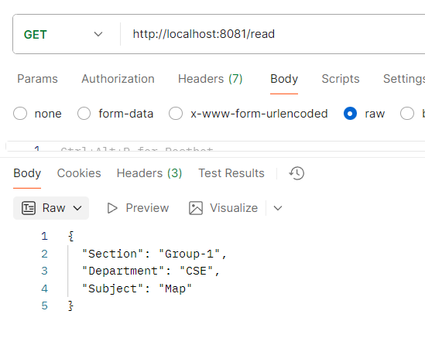

2) Updating Files Using Flow Triggers in Mule 4
In practical use cases, applications often need to automatically detect and process new or modified files—such as CSV, JSON, or text files—without manual intervention. MuleSoft offers the “On New or Updated File” component for this purpose, which continuously monitors a directory and triggers flows whenever changes occur.

Use Cases
- Auto-processing student records as soon as new files arrive.
- Updating employee or payroll data when a file is modified.
- Real-time monitoring of logs or transaction files.

Steps to Create the Flow
- Add “On New or Updated File” Component
  - Drag and drop the On New or Updated File component into the flow.
  - Configure it as follows:
    - Directory: Specify the folder to be monitored.
    - Frequency: 5
    - Start Delay: 0
    - Time Unit: Seconds
  - Mule will now check the folder every 5 seconds for any new or updated files.
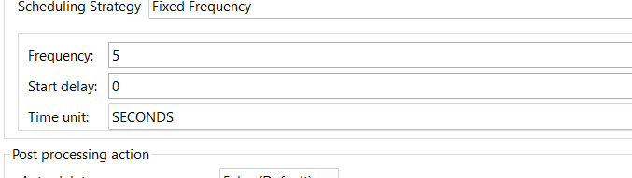
- Add a Logger Component
  - Add a Logger component after the file trigger.
  - Set the message to payload.
  - This will log the contents of the detected file whenever a change occurs.
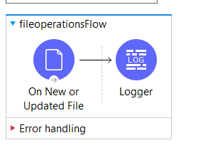
- Run and Test the Flow
  - Start the Mule application.
  - Place a new file in the monitored directory.
  - Check the logs – the file content will appear as the payload.
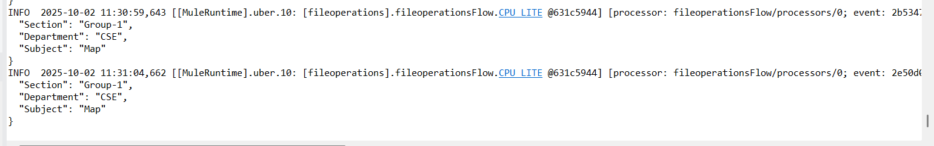
- Update the File and Observe Changes
  - Modify the contents of the existing file.
  - The flow will trigger again, and the Logger will display the updated payload automatically.
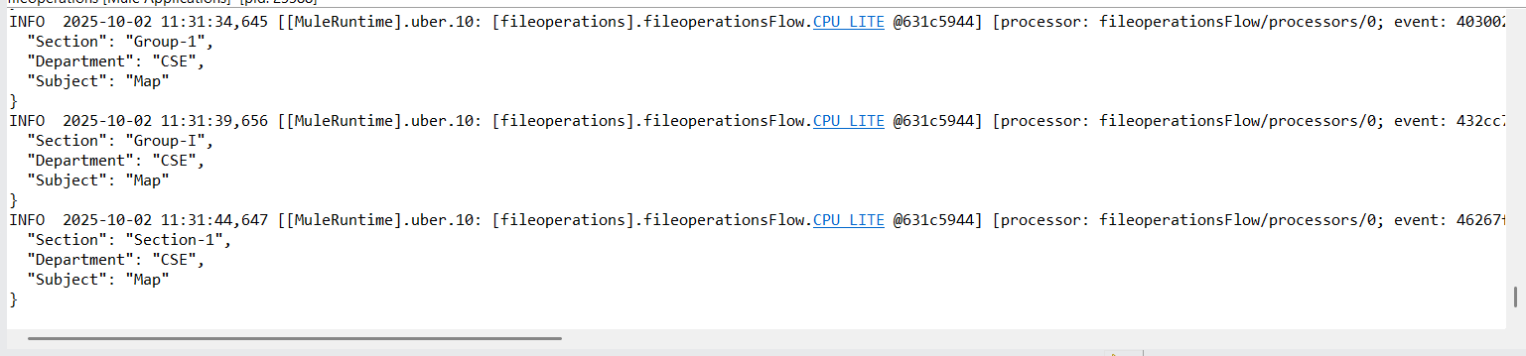

Benefits of Using “On New or Updated File”
- Enables real-time file tracking and automation.
- Removes the need for manual checks or repeated read operations.
- Can be paired with DataWeave to transform, validate, or enrich data before further use.
- Useful in batch jobs, reporting workflows, and system integrations.

